Mr. Henry,

This week was a pretty productive week for me in my project. I was able to arrange a time to meet with Full Time Developer at Orbital Shift and recent graduate of the UM Computer Science Department, Peter Clough. Pete helped me go through my project and make some suggestions that would make unit testing easier for me to perform.

One of his most helpful suggestions was to actual change my structure to a more 3 tier structure and implement a better BLL rather than doing a lot of my logic in the code behind. In my example I was using I had a lot of cases where I was directly accessing the database but this made it extremely difficult to write unit tests and in turn caused me to be stuck like I had described last time.

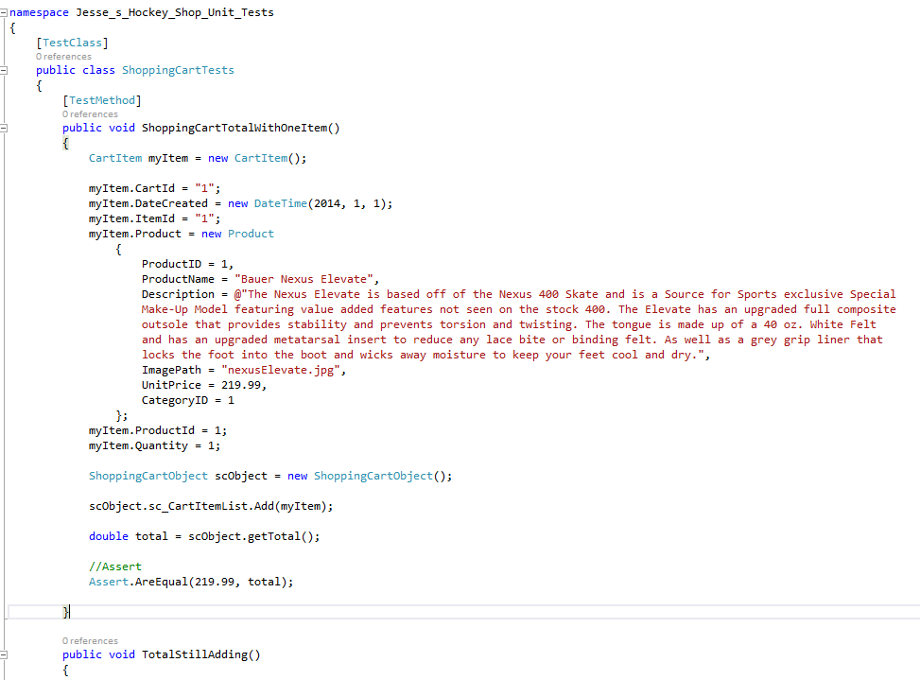

After Pete’s help I was able to successfully write my first unit test and from that I was ready to implement different cases that could all be written around that same structure.

When I wrote my paper the idea of Unit testing sounded very simple. You set up your case by implementing an instance of the method you want to test, you hard code in the data that you want to test it against, then you run your method to see if it equals what its supposed to equal. What I’ve quickly realized is that if you don’t have a good structure in the first place the test’s can't even help you.

------------------------------------------------

So far I feel like I’m getting a lot out of this Independent Study and as the semester is coming to an end I’m really working on getting into some other tests.

I wanted to follow up with you to see if you had a way for me to post my project on one of the CS web spaces so that I could try some of the other tests? Is that possible or should I try to use a trial service?

Also, I wanted to see if you’d have time to meet up this week. I like to get some ideas on next steps and get feedback about my work so far so I know if I’m on the right track.

Let me know if there is a better time otherwise maybe I’ll just plan to try and stop by during your office hours.

Thanks again,

Jesse Fulcher